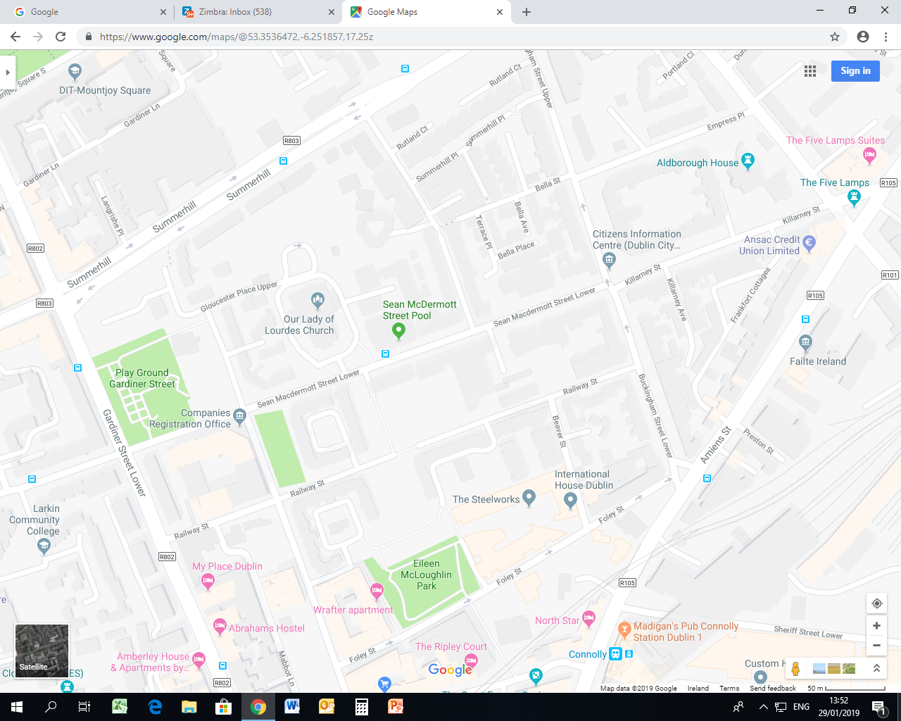

Walking

Driving

Beaver Street

**You are here**